HTML5

In this tutorial we will begin to look at HTML5 and how to use it to create and structure web page documents.

A web page document is (usually) written in a language called HTML (hypertext mark-up language). This is a mark-up language – these consist of directions (elements) that provide instructions to the web browser to indicate different parts of the page, creating the structure of the page. The latest version is called HTML5.

When a web page file is loaded into a Web browser it reads the elements and translates them onto the page (rendering the document) according to the way you have written the code.

Most HTML elements contain text content that they mark-up and so have a starting and ending tag that encloses it. The starting one (consisting of the element name in angle brackets (< >) e.g. <elementname>) turns a mark-up feature on, the ending one (the same as the opening one but the element name has a slash in it, e.g. </elementname>) turns it off. Example:

<p>A paragraph of text</p> is read by the browser to mean the text between the opening and closing tags should be a paragraph.

Singleton elements are ones that don’t enclose any text and are therefore only one-sided (don’t contain a closing tag). Examples include <br />, <hr />, <img />, <link /> and <input />.

Creating and saving a web page

A large number of tools can be used to create / edit web page documents. These range from editor software that allows the html to be entered largely by the user to tools like Adobe Dreamweaver that are capable of creating the HTML for you. As we want you to understand HTML, we will be using an editor program such as PHPStorm or Dreamweaver in Code View (only) to allow us to enter the HTML code ourselves. This will be useful when you are generating HTML dynamically using another programming language or need to know how to ‘tweak’ the HTML code etc.

HTML files (web page documents) have the .html file extension.

Task 1: Creating, saving and testing / viewing a basic web page

In this exercise you are going to create a basic web page.

Creating the web page

- Start a new html web page file using an appropriate web page editor program, making sure that you choose to make an HTML 5 document.

For this module EVERY web page that you create should have the following basic HTML structure as a minimum starting point, including the HTML 5 doctype. An explanation of the html is provided under it

<!doctype html>
<html>
<head>
<meta charset="utf-8">
<title>Untitled Document</title>
</head>
<body>
</body>
</html>
doctype – identifies the type of mark-up language used in a web page
<html></html> - specifies the language for the web page and encloses the documents content, divided into two, a HEAD section and a BODY section
<head></head> - head section: contains information about the web page document that describes it. Can include only certain elements like the <meta> one provided which specifies the character set, and <title></title> for the page title that provides page identity
<body></body> - body section: contains text and elements that display in the Web page document

- Between the <title></title> tags enter the text My first University web page. This will be the title of the web page (this appears in the title bar and not on the page

- On a new line after the <body> tag enter the following to add a main heading to your web page:

<h1>My page</h1>

Saving the web page

- Save the file to your ‘u’ drive:
  - Create a new folder called webTechnologies on your u drive to store your web page files in
  - Save you web page into your webTechnologies folder with the filename first.html

Notes
Always use lowercase filenames (with no spaces in them) for all your web files as web servers (like the one you will be using later) can be case sensitive and this can cause you problems when you transfer copies of your files there.

It is also a good idea to use largely lowercase folder names without any spaces – rather than spaces it is recommended that you use ‘camel case’ (a capital for the start of the second word) if you need to join words as we did above.

Testing / viewing the web page

There are several ways to test/view web pages that are stored ‘locally’, e.g. on a network drive, a USB stick etc. However, we would like you to do the following to view your web page.
- Open the Firefox web browser  - From the File menu choose File>Open and then navigate to and open your web page ‘first.html’. The web page should look something like that shown opposite. If not check the code | 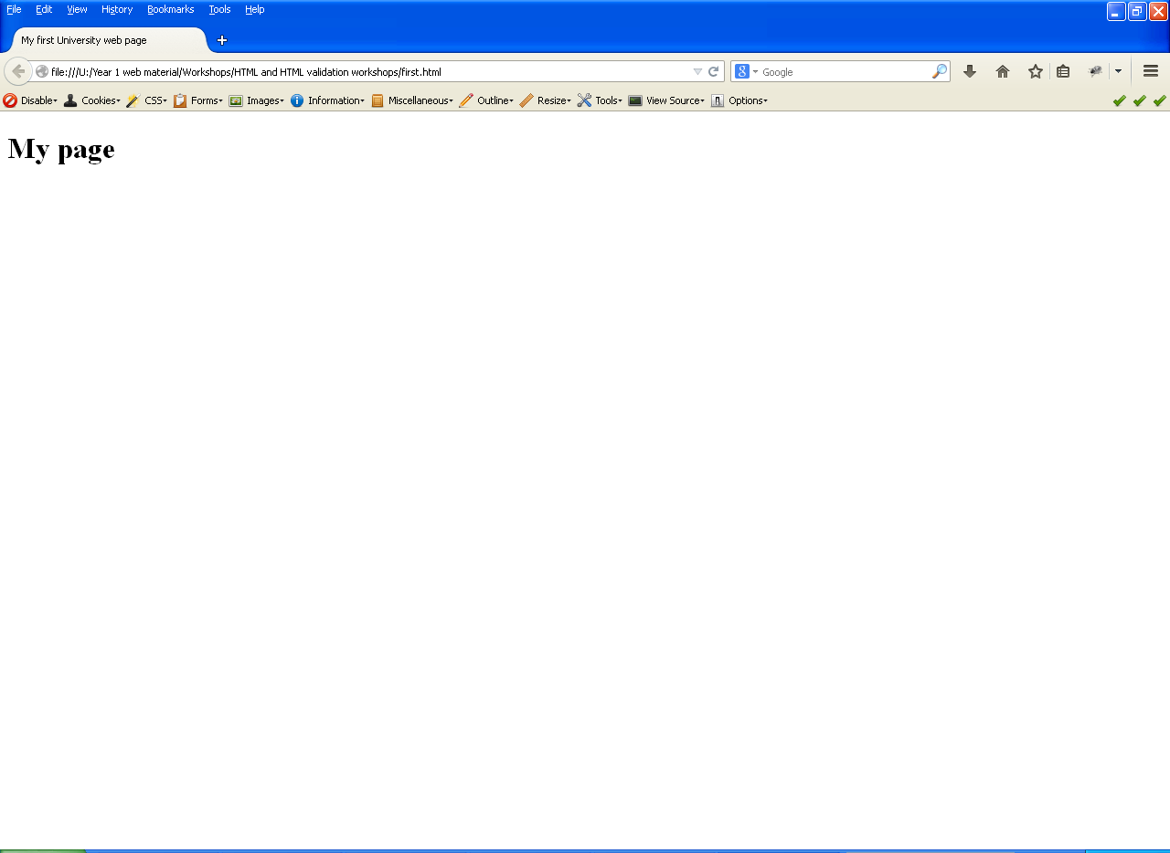

Task 2: Modifying our web page

Here we will modify the web page that you created in task 1. To modify the web page, you need to have the relevant file open in the editor, make changes to the text in the file and then save the changes.

- On a new line after the text <h1>My page</h1> enter the following to add a paragraph to your web page after the main heading:

<p>Hello, this is my first web page at University.</p>
- Now re-save the web page and reload it in the web browser. The web page should look something like that shown opposite | 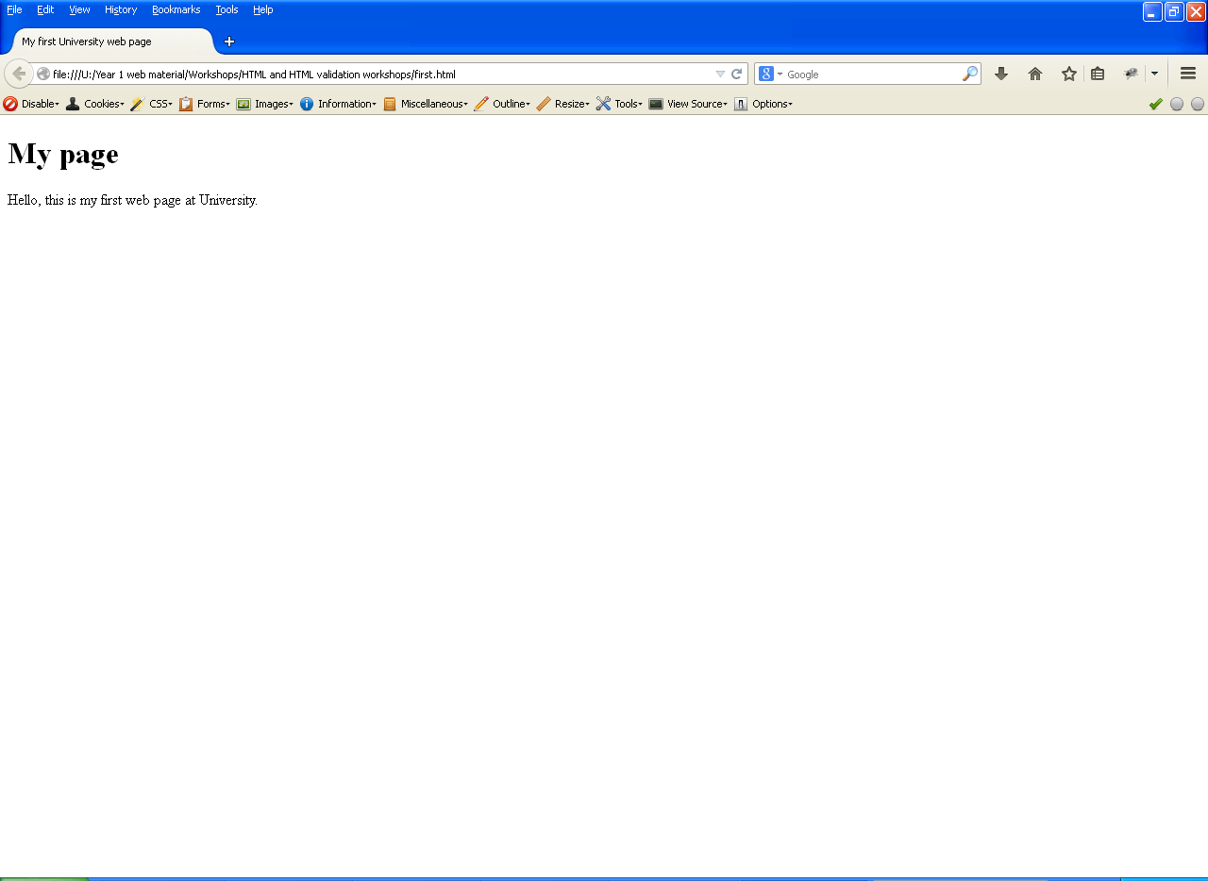

Task 3: Creating a small web site
In this task you are going to create a small web site that will bring together and extend what we have covered so far, using an appropriate web page editor program and only HTML elements.

- The content of the web pages should be about your favourite place in the world, i.e. a country, town or city you like to visit or dream of visiting. One of the web pages should contain further information about one of the points/topics on the other web page. The two pages must be based on the basic HTML5 element structure included earlier and should make use of the following features of HTML:

  - Different headings (e.g. a heading one, heading two etc. as appropriate) for new sections or subsections of a page to help give it structure
  - Several paragraphs containing relevant text, including some text that is emphasised in some way
  - A numbered list and a bulleted list
  - Links to link the two web pages
  - At least one relevant image on one of the pages
  - A table
  - HTML comments

HTML5 introduced a number of elements that can be used to define (section) specific parts of a page, such as headers, footers, navigation, a main area, articles, asides and general sections.

- Use appropriate HTML5 elements to group the content of the pages into defined sections as appropriate. For example, place main page navigation links in between <nav></nav> tags.  Include a header, navigation area, a main area, some sections and a footer area in each page. At this stage it is not necessary to include an article or an aside. |  | <!doctype html>  <html>  <head>  <meta charset="utf-8">  <title>Title text</title>  </head>  <body>  <header></header>  <nav></nav>  <main>  <section></section>  <section></section>  </main>  <footer></footer>  </body>  </html>
Resources to help you
To help you create the web pages you may want to use the following resources as a reference that contain information on different types of html elements and their uses with lots of useful content, e.g. on how to create paragraphs, lists, add images, tables etc.
- The Word document ‘Some common HTML elements’ provided on blackboard
- HTML Beginner Tutorial - http://htmldog.com/guides/htmlbeginner/
- HTML Intermediate Tutorial (some parts of this may not be relevant yet but may be useful later) - http://htmldog.com/guides/htmlintermediate/
- HTML5 Doctor, helping you implement HTML5 today. Available at: http://html5doctor.com/
- HTML5 element list - Web developer guide | MDN
https://developer.mozilla.org/en/docs/Web/Guide/HTML/HTML5/HTML5_element_list
- Sectioning | HTML Dog - http://htmldog.com/guides/html/intermediate/sectioning/

